

Department of Computer Science and Engineering

Fall-2022

Course Code: CSE347

Course Title: Information System Analysis and Design

Project Report on

**Online Railway Ticket Reservation System**

**Submitted by:**

Name: Fatema Akter

ID: 2020-1-60-115

Name: Abdullah al Tamim

ID: 2020-1-60-127

**Instructor:**

Md. Mohsin Uddin

Senior Lecturer

Department of CSE

East West University

1. **Introduction:**

* Problem Definition: Booking tickets for trains especially in an overpopulated country like Bangladesh often becomes miserable. And it becomes pathetic during vacations. Online Railway Ticket Reservation System is aimed to provide customers the facility to book tickets for a train online in a convenient way to travel from a particular source to the destination. Users of the system will be able to visit train schedules from source to destination, know about the availability of seats, choose seats manually or automatically, pay online, and print their e-tickets. They will be able to book their required tickets from anywhere and at any time. So, this system will save their time and energy as they don’t have to wait for a long time in the queue to book tickets anymore.
* Motivation and Challenges: Since a lot of people choose the train as their first priority for traveling so the system is going to be very helpful for them. Since the number of users using the system at a time is numerous, so keeping the system reliable and consistent is going to be a very big challenge. That’s why we will use relational database management system. Another challenge will be verifying the NID card number because we don’t have any such database from which we can check whether the given NID number is valid or not. So, for simplicity, we assumed that the users would provide a valid NID card number.

1. **Non-Functional Requirements:**
   * Security: The system must ensure security first. One user cannot see the other user’s information. Users cannot change any system-related internal information. Only the technical team can change that information.
   * Efficiency: The system should be efficient it should not take so much time to run the program. Our system cannot afford too much time in data processing also it requires a vast size of storage capacity for data that’s why the performance of the system should be good enough and memory management should be ideal.
   * Usability: The system should be user-friendly and easy to use so that any type of user can use it easily.
   * Availability: Since the main motive of the system is to save peoples’ time so they should be able to use it at any time and from anywhere.
   * Ethical: Ethics should be maintained while developing and maintaining the system. There should not be any gap by which raw data of users can be accessed and used for personal benefits.
   * Environment: The system should be environmentally friendly. It should be built in such a way that it utilizes the usage of the CPU and servers to perform its operation which impacts the environment less physically and save energy.
   * Dependability: The system should be dependable so that the users can trust on the reliability of the system in terms of security and privacy.
   * Accessibility: The system can be accessed by only valid users. Unidentified users should not be able to book tickets and visit any user’s information.
   * Flexibility: The system user base is very broad that’s why it should be able to serve many users at a time if needed.
   * Disaster recovery: The database of the system should have a full backup so that it can recover any disaster if occurs.
   * Interoperability: The system should be able to communicate or exchange information with other systems through application program interfaces.
   * Cost: The system should be cost-effective but security and reliability should not be compromised.
2. **Functional Requirements:**

* Sign up: Users will be able to register an account if they don’t have any already. To register an account, they must provide their NID card number, phone number, and valid email address.
* Sign in: The users will be able to visit the schedule of the trains without any account. But if they want to book any ticket then they will be needed to be logged in state.
* Password resetting system: If any user forgets his or her password then he/she can recover his/her account by email or phone number.
* Searching option for trains: Passengers will search for trains by providing their source, destination, journey date, and class. Lastly, they will provide the number of adult and child passengers.
* List of available trains: If there are trains available based on searching criteria then the users can see the train’s name, train id, arrival time, and departure times. Also, they can see the cost for the different classes of seats. Moreover, they can see the number of tickets available for any train.
* Option for choosing seats based on availability: If there are enough empty seats available, the users can book them. They can either choose the seats manually or automatically. At a time, they will be able to choose a maximum of 4 seats. There must be at least one adult passenger for any child passenger ticket. While the users choose the seats, the net total payable amount will be shown.
* Option for confirming booking by paying through mobile banking or online banking system: Users will be able to confirm the booking by paying online. They will be able to pay through Visa card, Master card, American Express, DBBL nexus pay, Bkash, and Rocket.
* Automatic emailing with the e-ticket: When the payment is successful the user will receive an email with the e-ticket in a downloadable format (PDF). They can also download the ticket from the system at any time.
* Option for updating user information: Passengers can update their information at any time but they cannot change their NID number, email, or phone number.
* Option to find all previous and upcoming journeys: Passengers can find all their previous journeys’ history. And if they have any booked tickets then they can see them on their upcoming journeys.
* Option to contact the technical support team if there are any bugs: If any misfunction is found then the users will be able to contact with the technical support team.

1. **Technologies:**

* Programming Language: For this project, we will use python as the backend programming language. Also, we will use Django as the web framework which enables rapid development with security.
* Database: For the database, we will use Oracle. Because it has a wide range of community support and assistance also it comes with great ease to implement in big projects.
* Others: For the frontend segment we will use HTML modified by other technologies like CSS, Bootstrap, and JavaScript. Bootstrap will help to get responsiveness in our website. We will use CSS to control the presentation, formatting, and displaying of the layout. Moreover, we will use JavaScript to control the behavior of different elements on the application view panel.

1. **Use Case Diagram:**

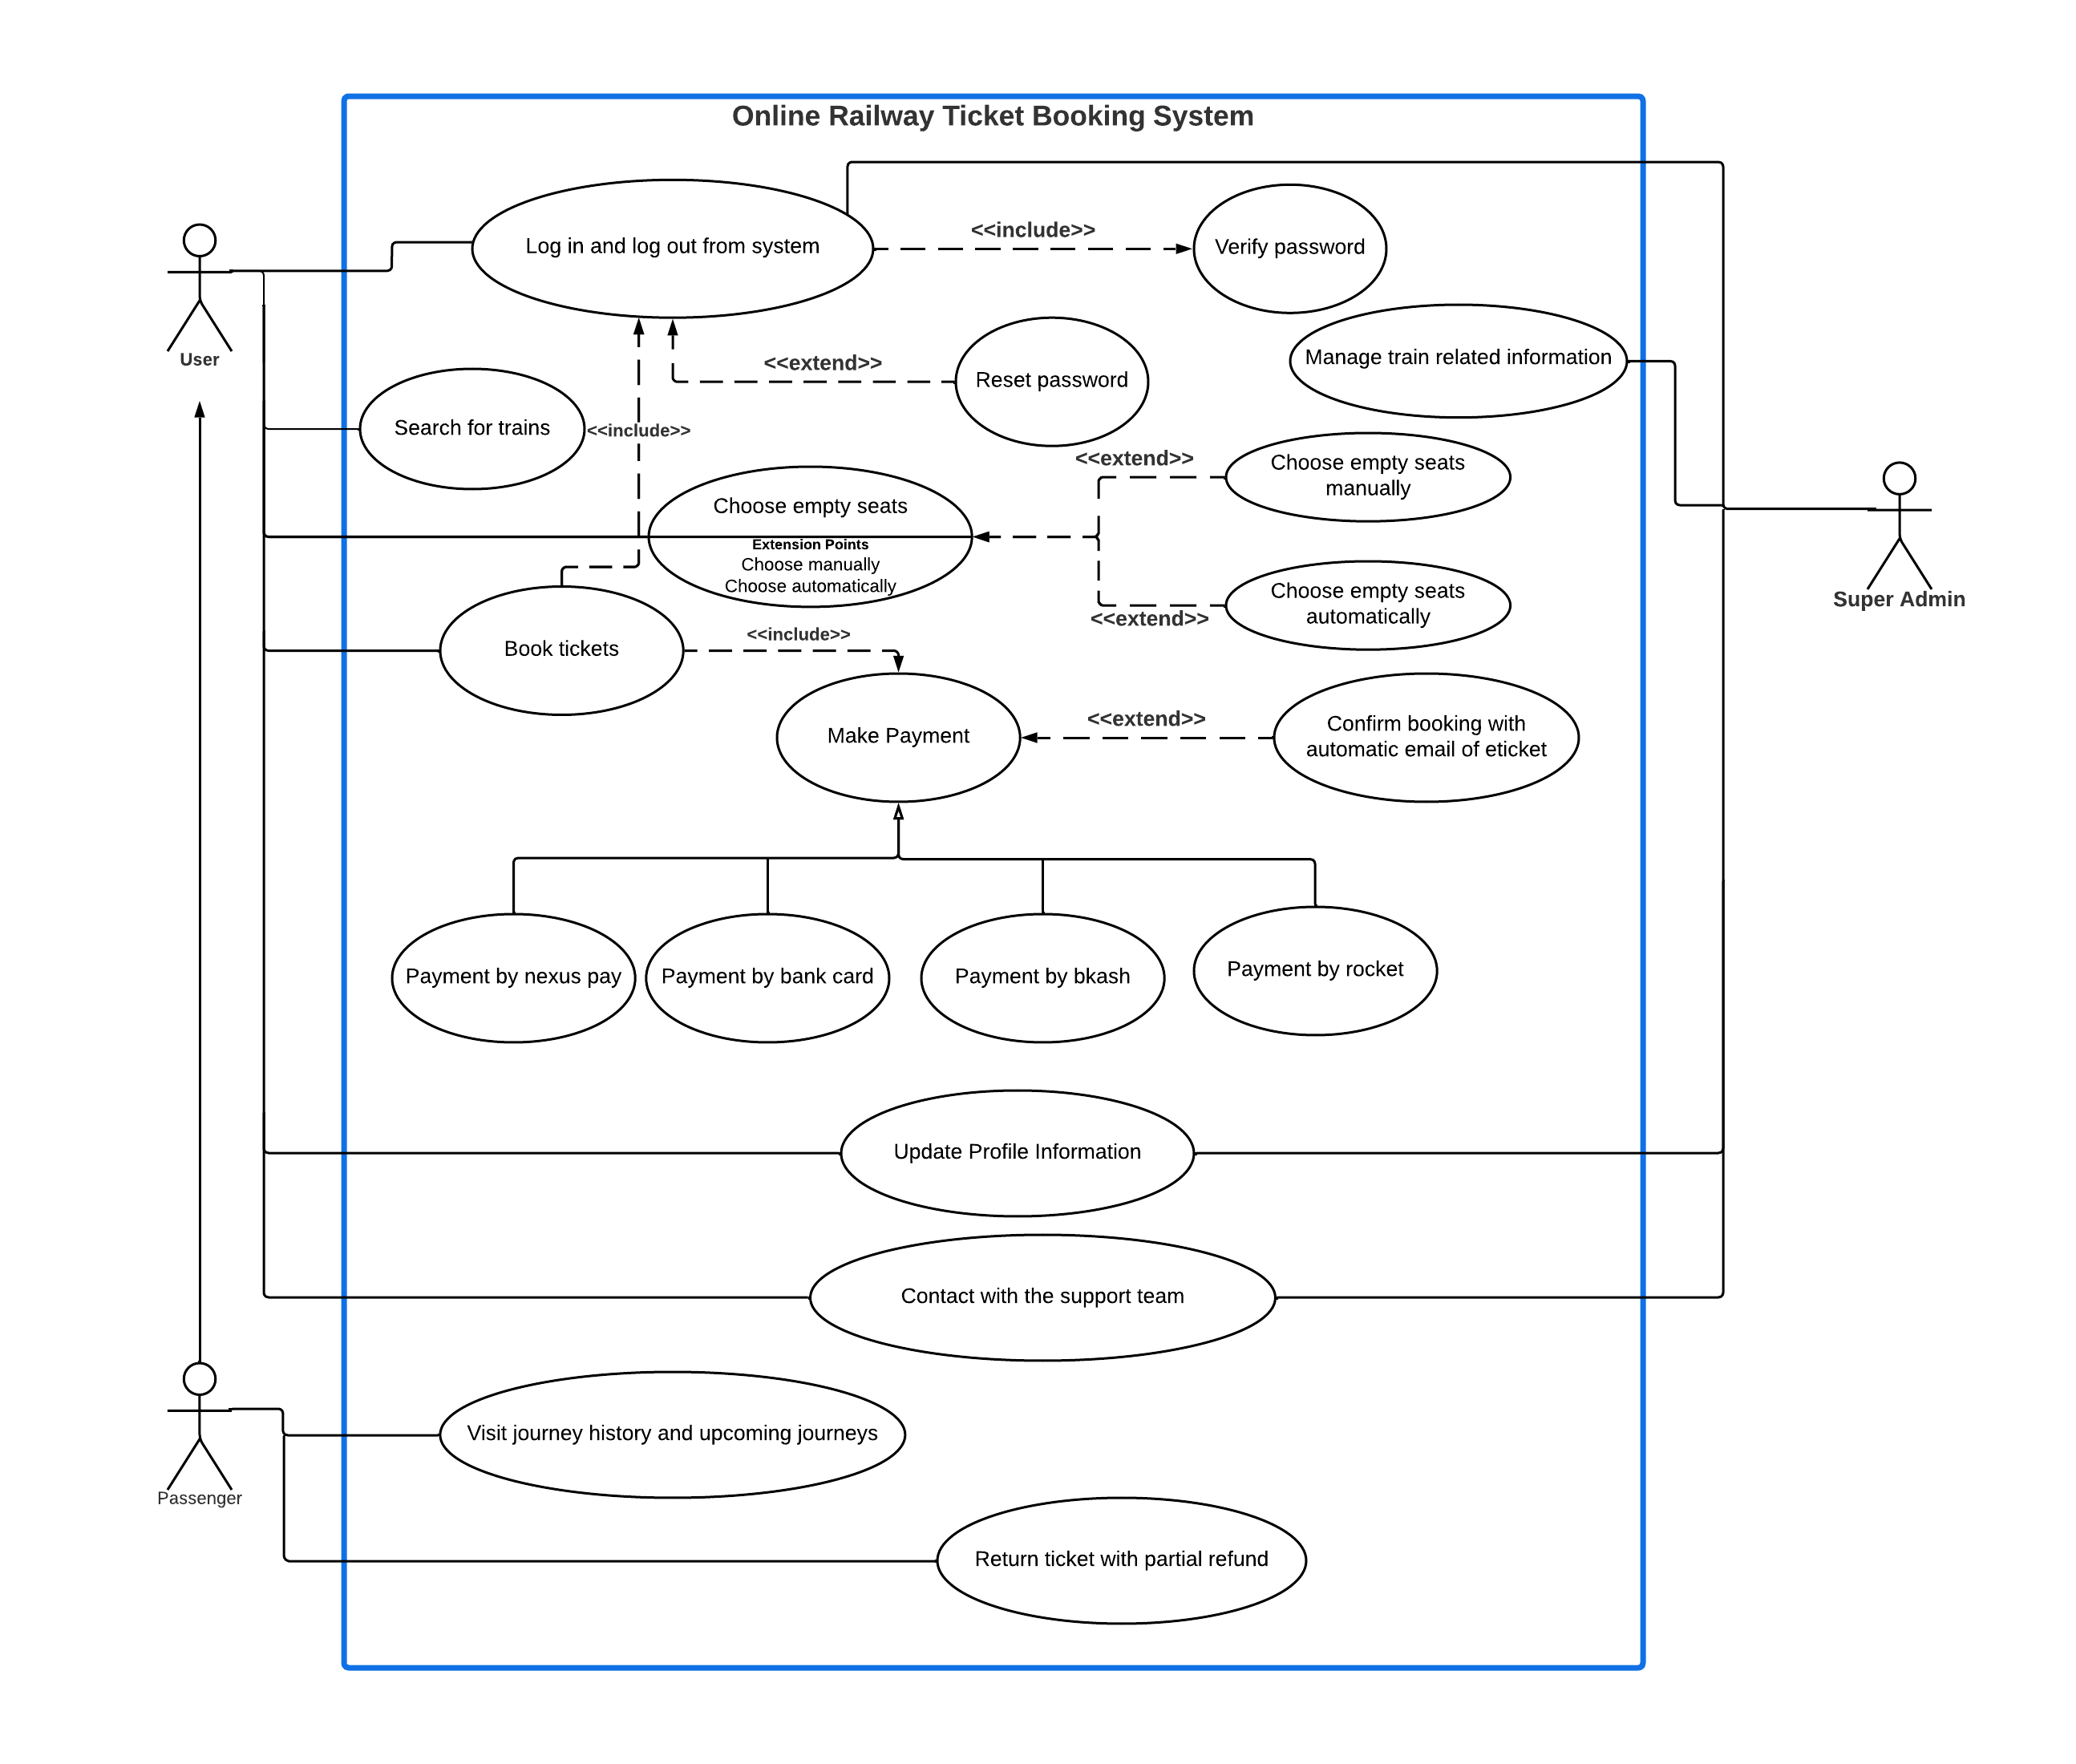

1. **UML Class Diagram:**

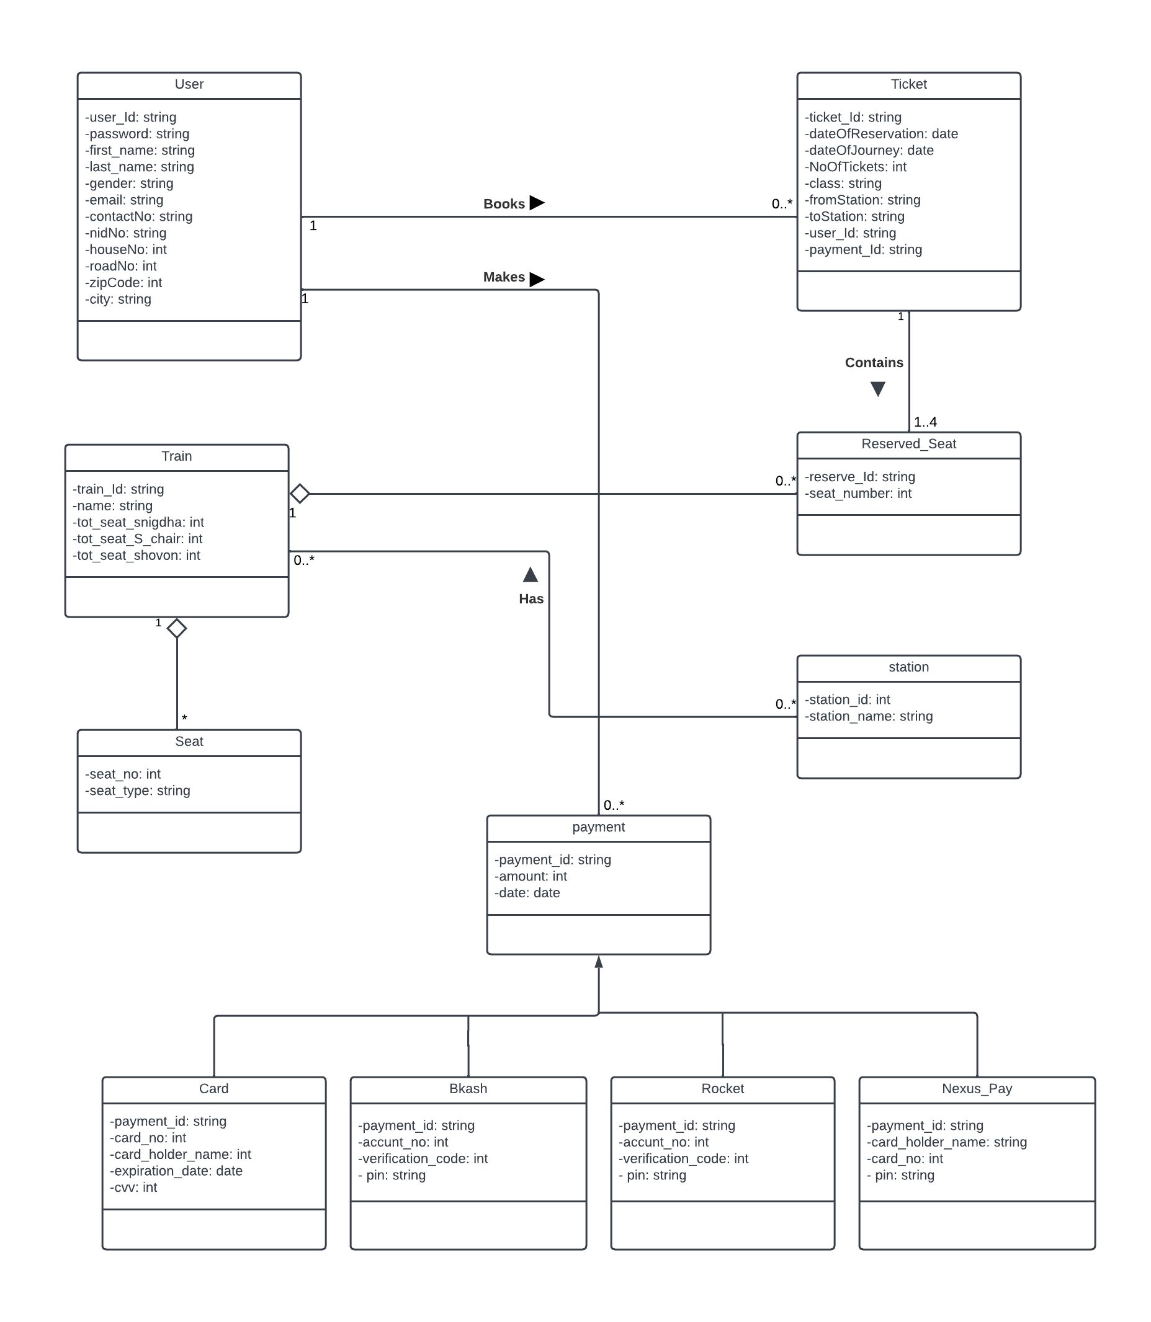

1. **ER Diagram:**

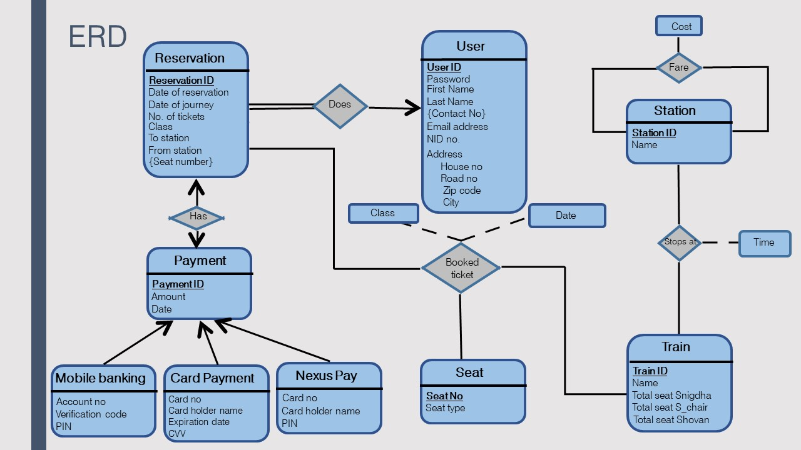

1. **Sequence Diagram:**

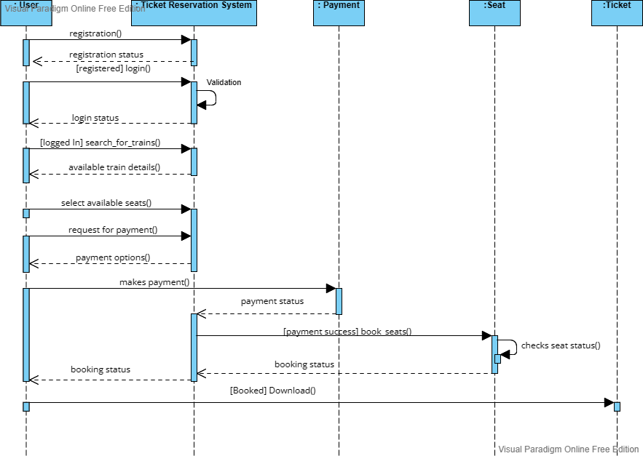

1. **Activity diagram:**

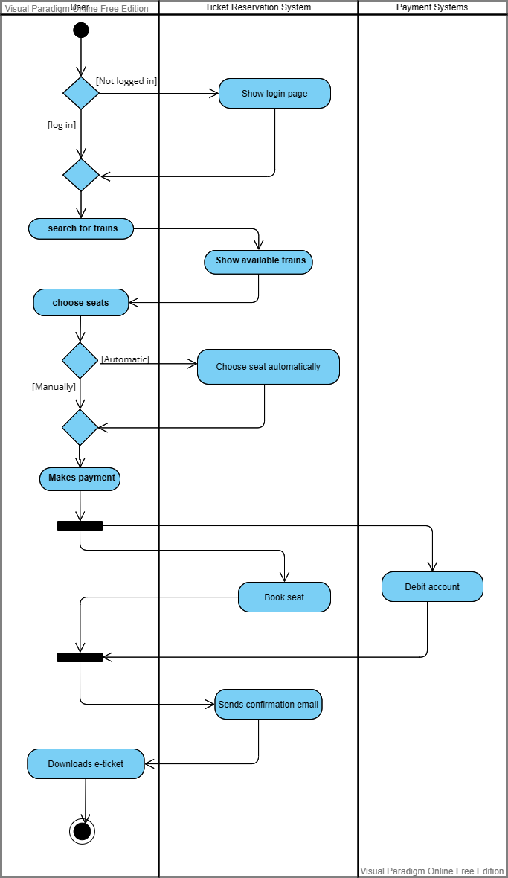

1. **Graphical User Interface of the website:**
2. Registration Page:

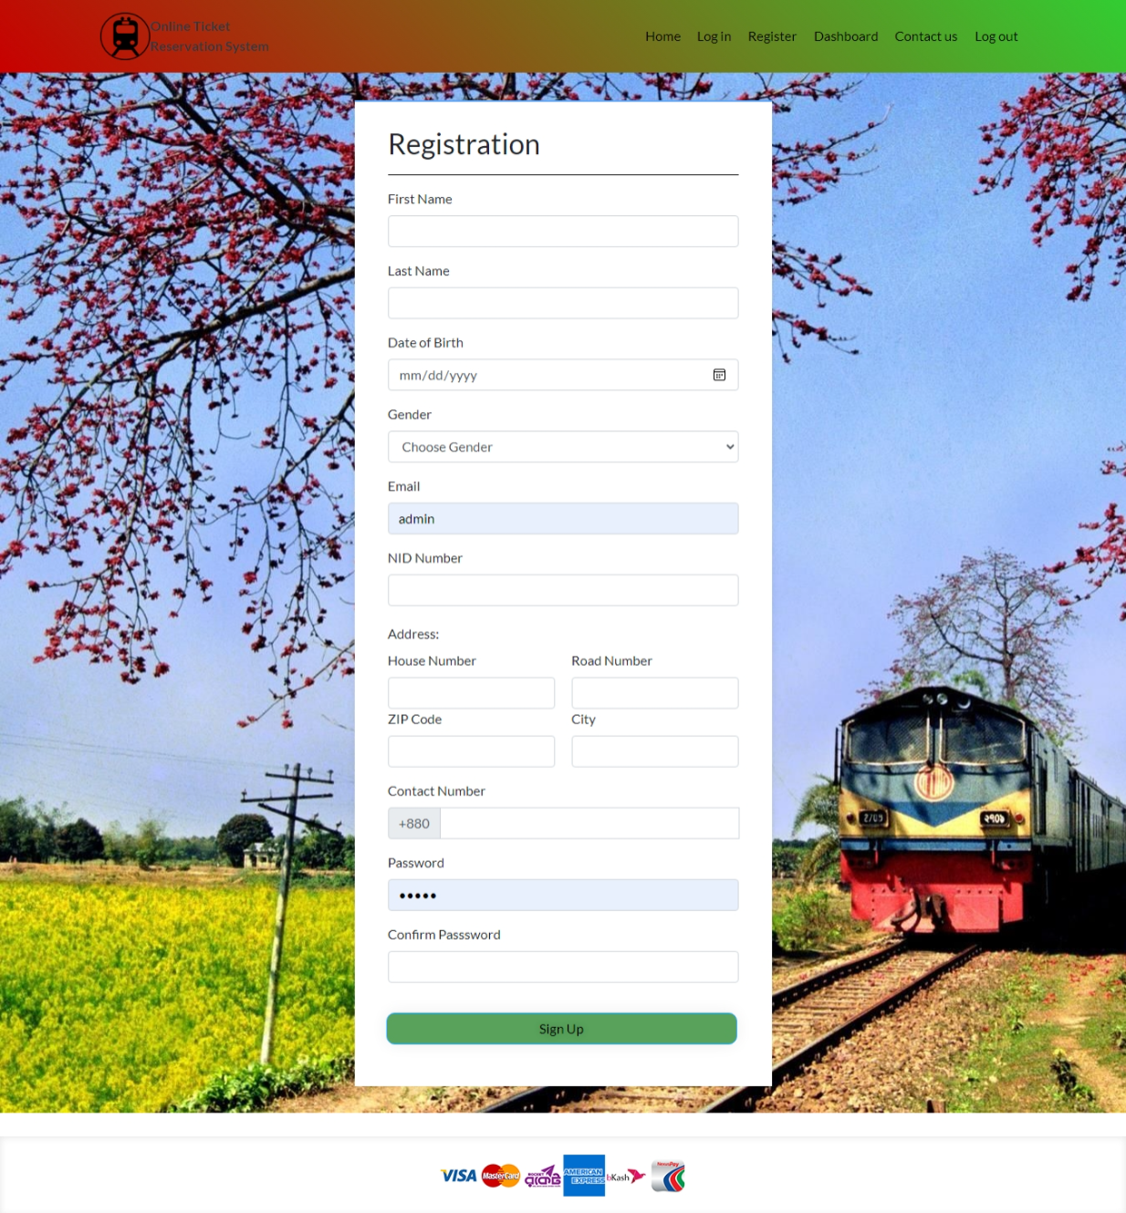

1. Login Page: 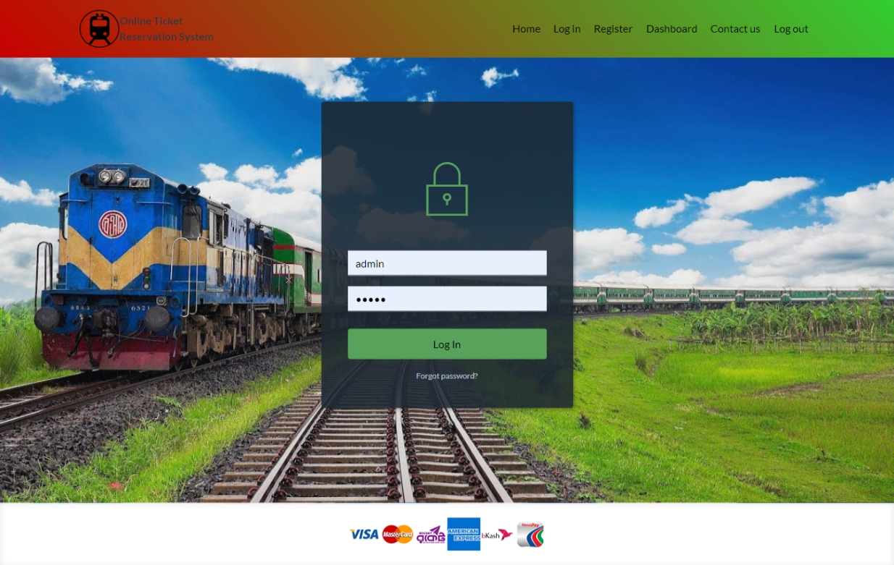
2. Forget Password page: 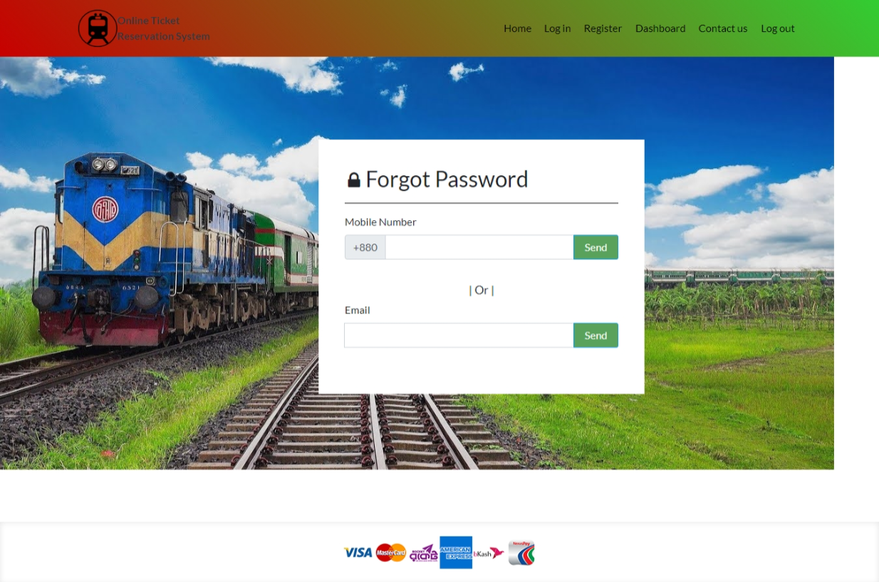
3. Home page: 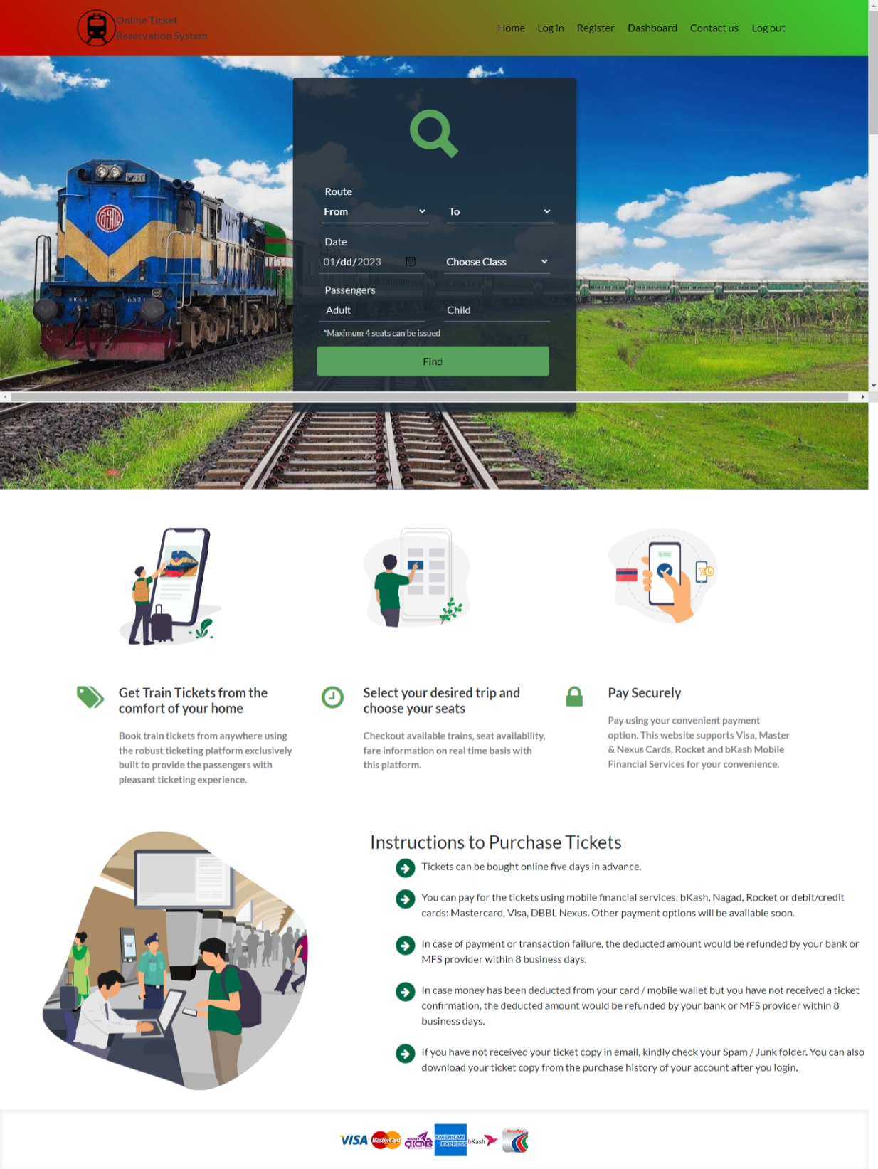
4. Train list page: 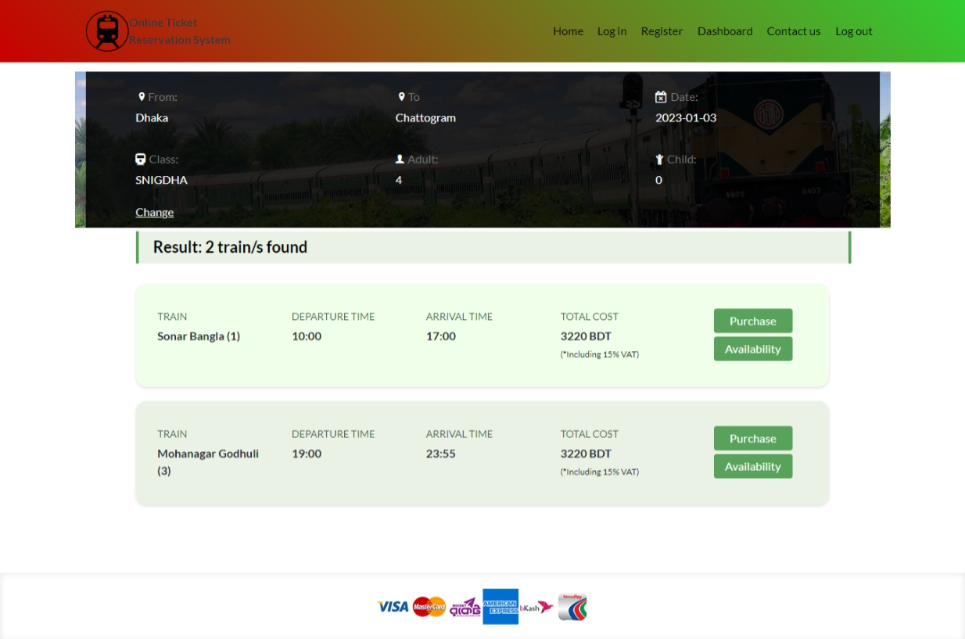
5. Automatic Seat Selection page: 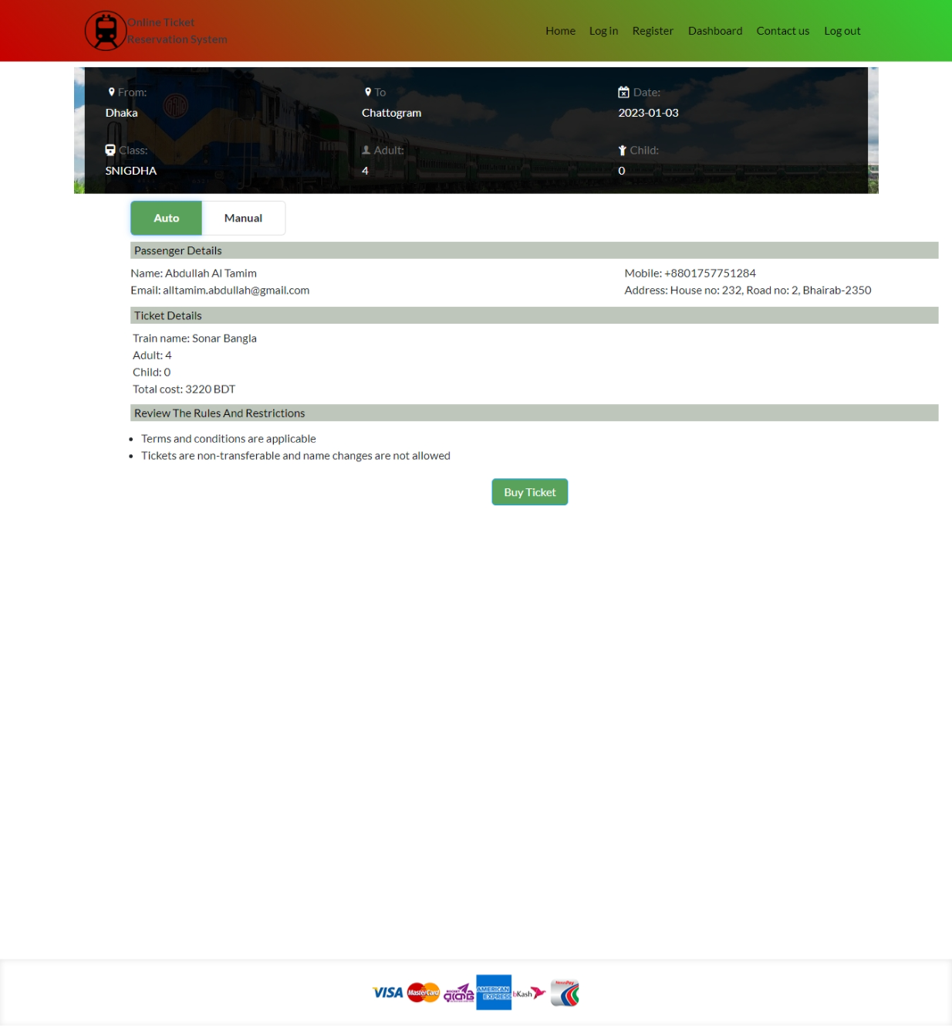
6. Manual Seat Selection Page: 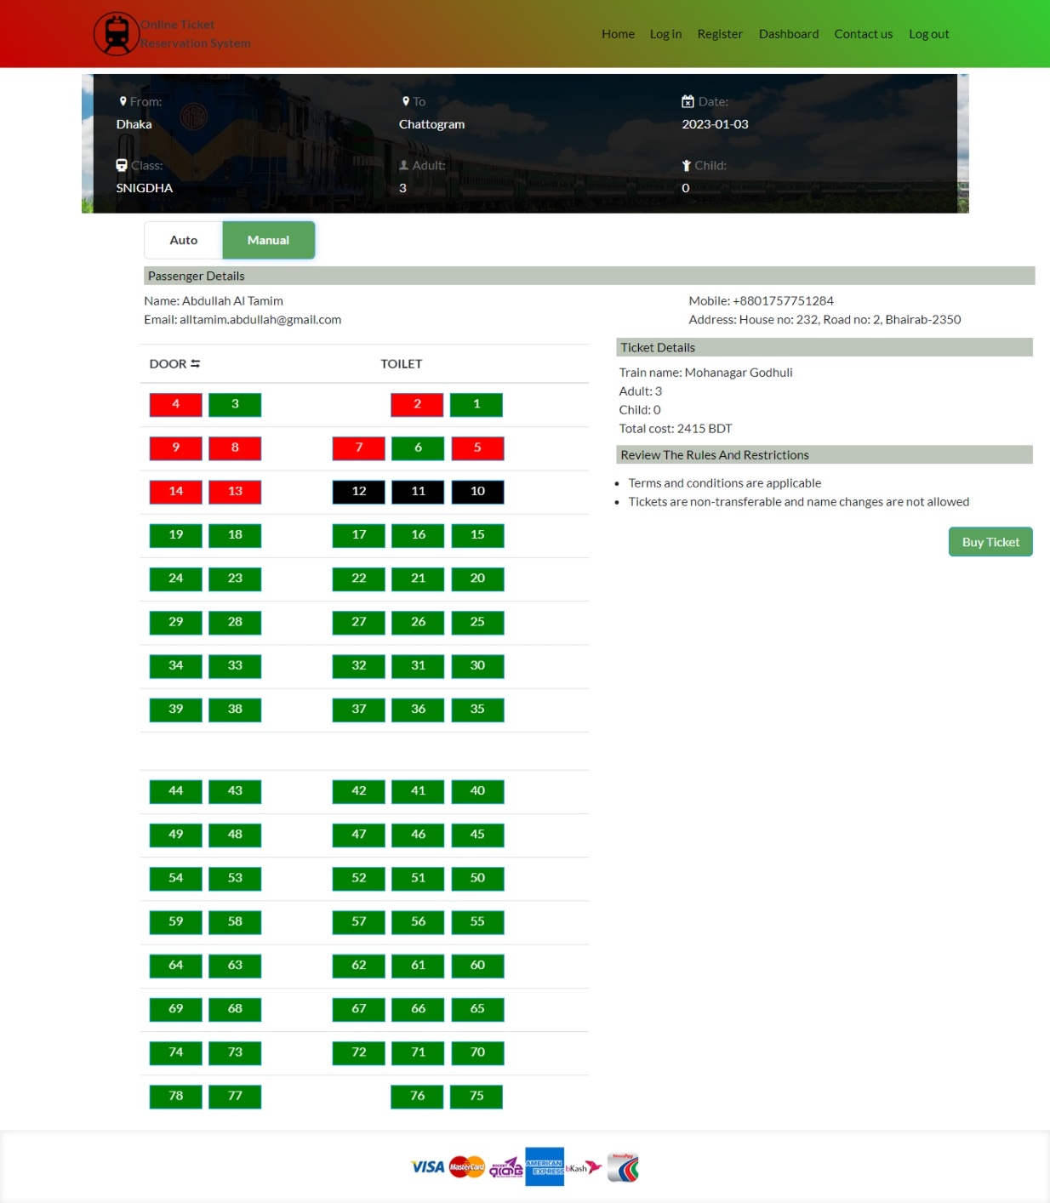
7. Payment Selection page: 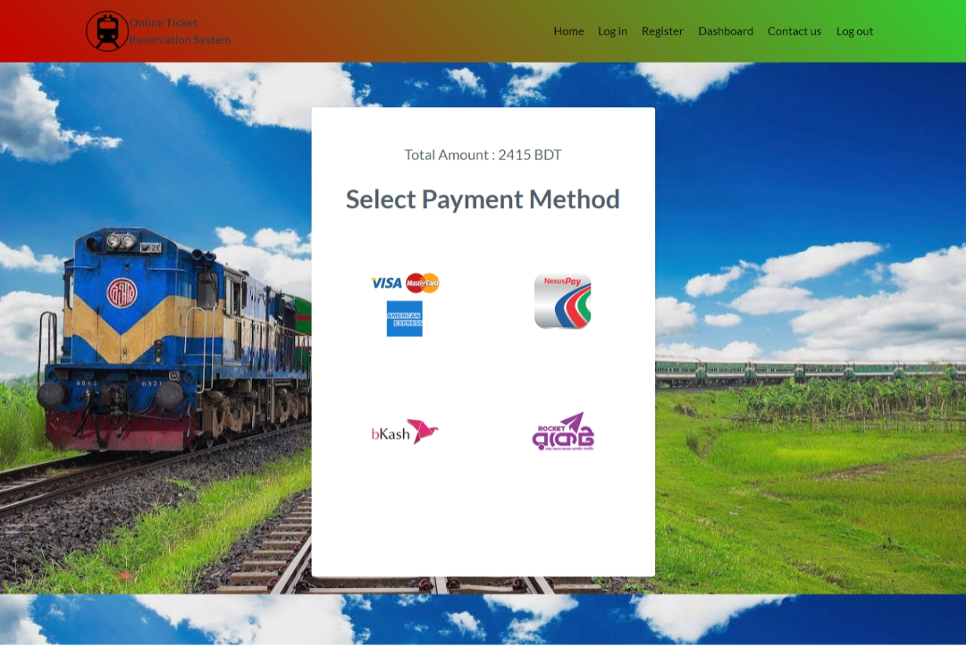
8. Payment with Bkash page: 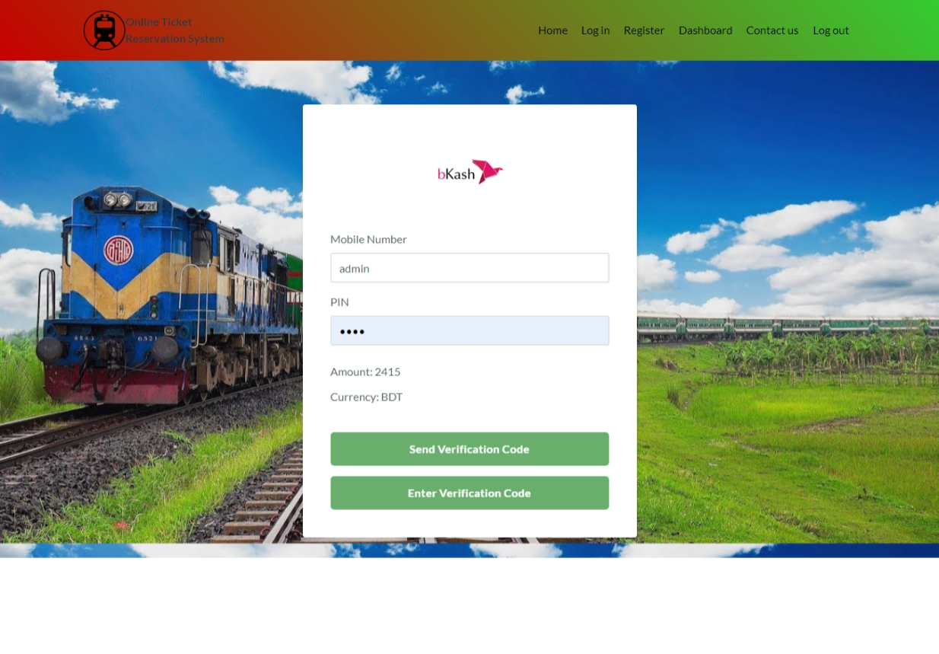
9. Payment Successful Page: 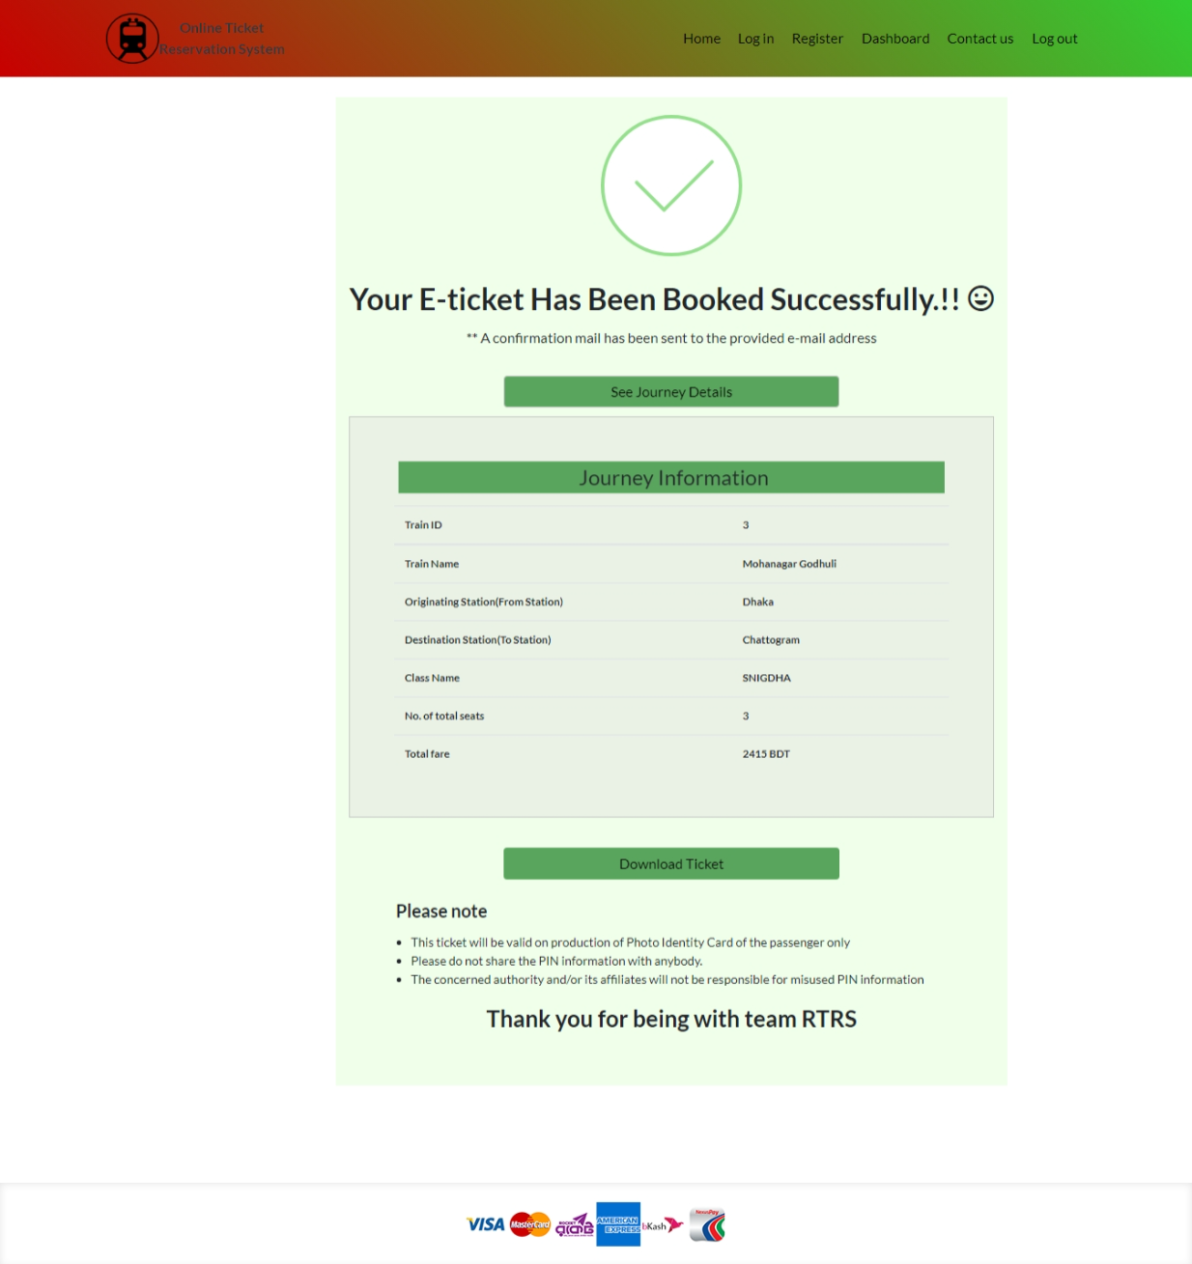
10. E-Ticket in pdf format: 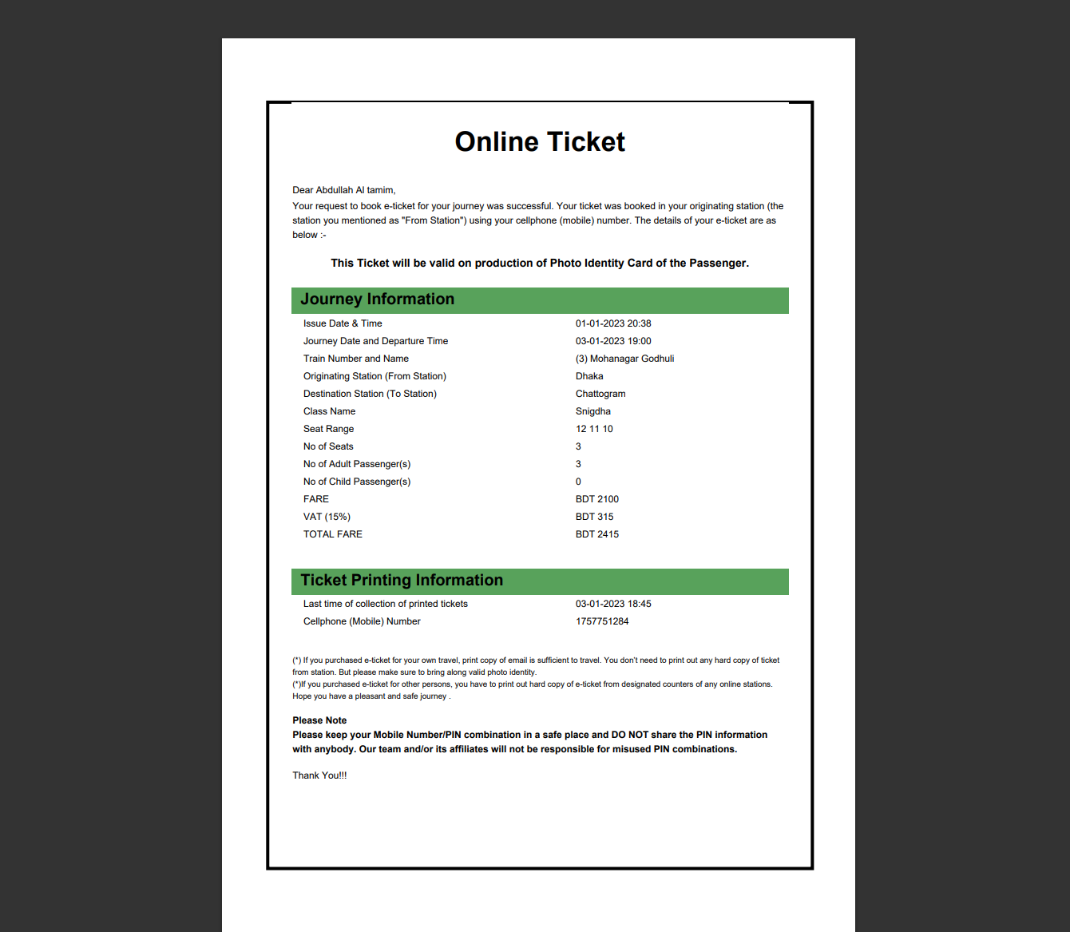
11. Update User Profile Page: 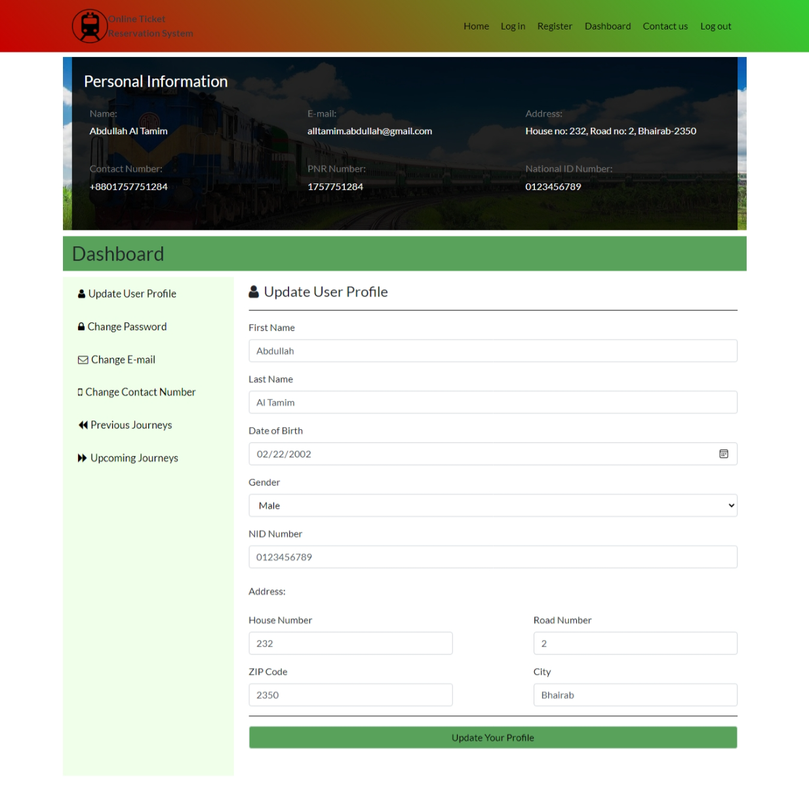
12. Password Changing Page: 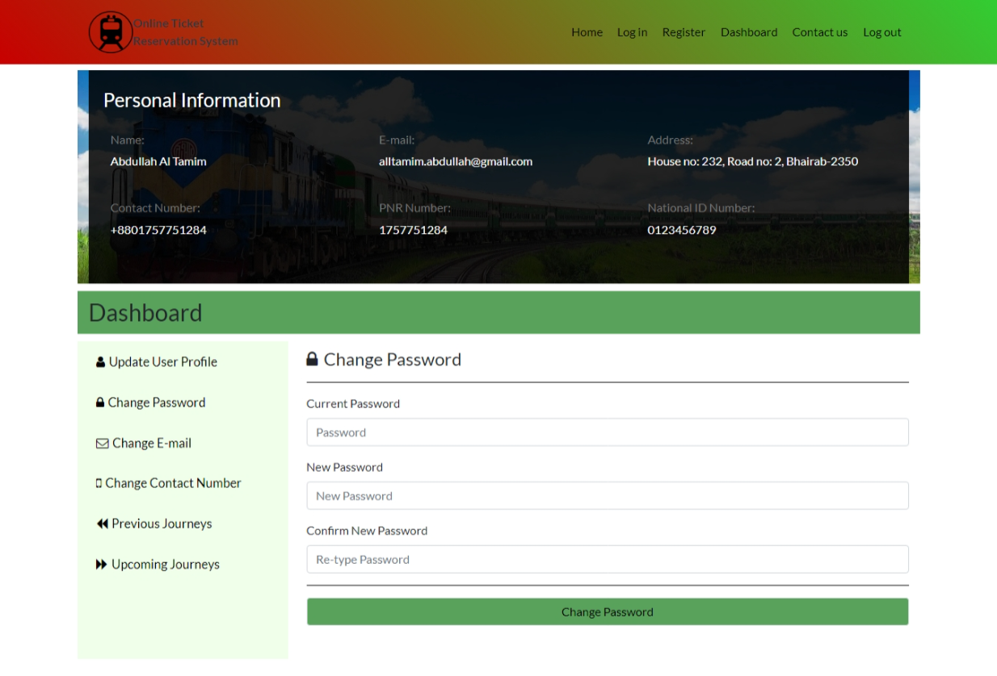
13. Change Email Page: 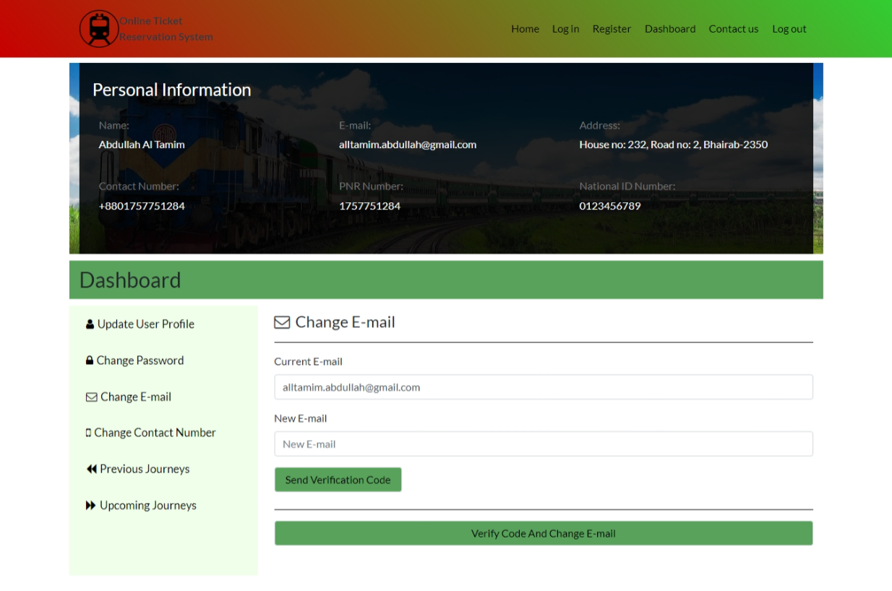
14. Change Contact Number Page: 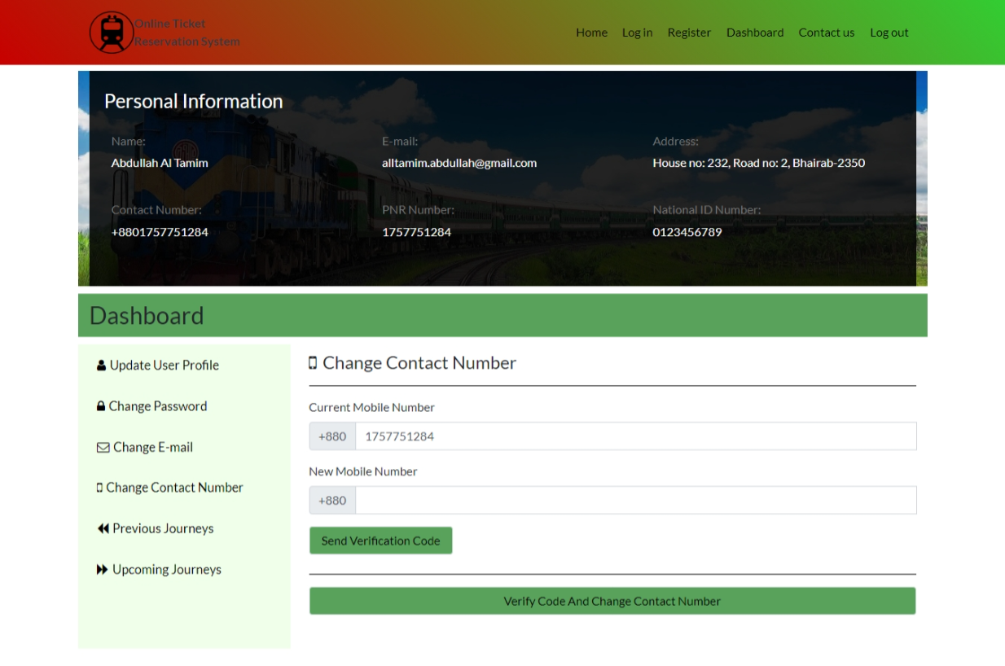
15. Previous Journey Page: 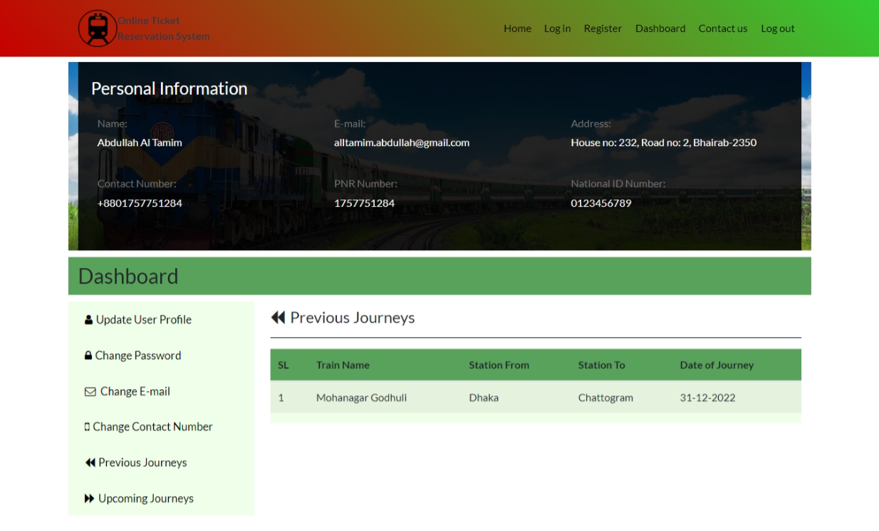
16. Upcoming Journey Page: 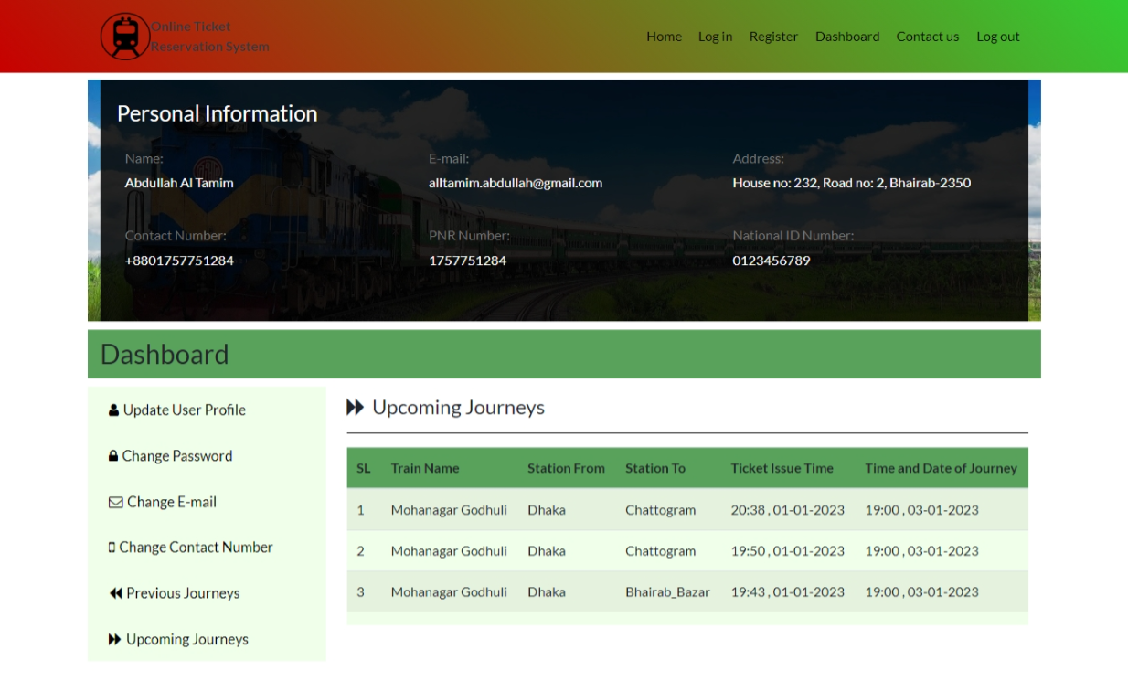
17. Contact Us Page: 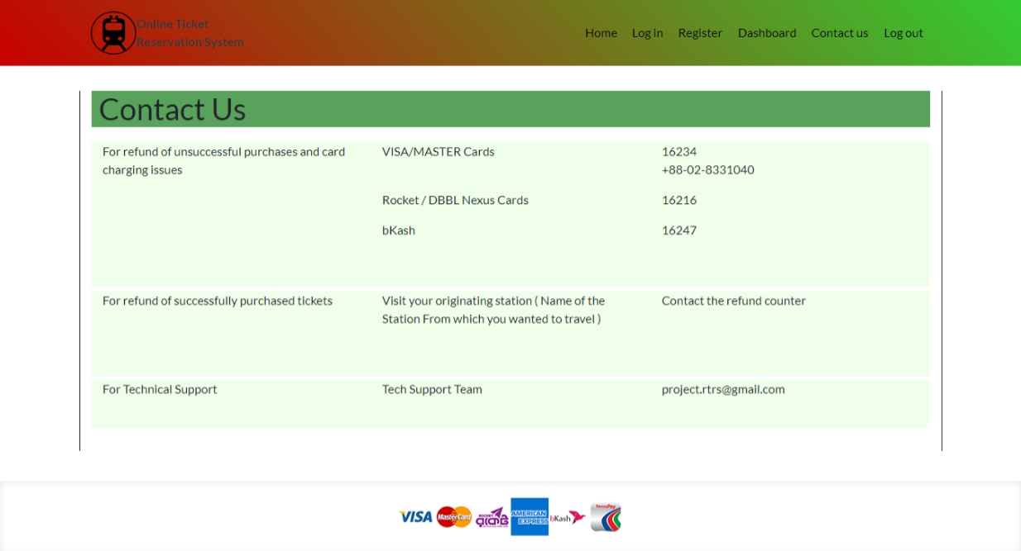
18. Admin panel page: 